## Example 5

The first step is to read in the data.

dat<-read.csv("example5.csv")

The next step is to check out the structure

str(dat)

## 'data.frame': 50 obs. of 2 variables:  
## $ group: Factor w/ 2 levels "control","experimental": 2 2 2 2 2 2 2 2 2 2 ...  
## $ rt : num 273 321 294 321 271 ...

As we can see dat is a data frame with two variables: group and rt.

mean(dat$rt[dat$group=="experimental"])

## [1] 289.5517

mean(dat$rt[dat$group=="control"])

## [1] 310.517

NOTE: after I enter bits of code, I run the code or knit the document to see what the results were of my analyses. Thus, I'm going back and forth between running code and checking the output to make sure it appears correct.

By looking at the means it appears that the experimental group completed the task faster than the control group.

Now I'll perform an independent t-test to see if my intuition was correct.

t.test(dat$rt[dat$group=="control"],  
 dat$rt[dat$group=="experimental"],  
 var.equal=TRUE)

##   
## Two Sample t-test  
##   
## data: dat$rt[dat$group == "control"] and dat$rt[dat$group == "experimental"]  
## t = 3.1478, df = 48, p-value = 0.002826  
## alternative hypothesis: true difference in means is not equal to 0  
## 95 percent confidence interval:  
## 7.574029 34.356624  
## sample estimates:  
## mean of x mean of y   
## 310.5170 289.5517

Examining the results of our t-test we can see that individuals in the experimental group performed the task quicker than individuals in the control group, t(48) = 3.15, p = .0028.

Now, I'll run an independent t-test with the alternative hypothesis that the experimental group is faster than the control group.

t.test(dat$rt[dat$group=="control"],  
 dat$rt[dat$group=="experimental"],  
 var.equal=TRUE,  
 alternative="greater")

##   
## Two Sample t-test  
##   
## data: dat$rt[dat$group == "control"] and dat$rt[dat$group == "experimental"]  
## t = 3.1478, df = 48, p-value = 0.001413  
## alternative hypothesis: true difference in means is greater than 0  
## 95 percent confidence interval:  
## 9.794621 Inf  
## sample estimates:  
## mean of x mean of y   
## 310.5170 289.5517

Examining the results of our t-test we can see that individuals in the experimental group performed the task quicker than individuals in the control group, t(48) = 3.15, p = .0014.

In order to create a figure of the data, I need to load the ggplot2, gplots, and dplyr libraries.

library(ggplot2)  
library(gplots)

##   
## Attaching package: 'gplots'

## The following object is masked from 'package:stats':  
##   
## lowess

library(dplyr)

##   
## Attaching package: 'dplyr'

## The following objects are masked from 'package:stats':  
##   
## filter, lag

## The following objects are masked from 'package:base':  
##   
## intersect, setdiff, setequal, union

Next I need to use dplyr to summarize the data and find the means and standard errors of the means for the different groups.

temp<-dat%>%group_by(group)%>%  
 summarize(means=mean(rt), sems=sd(rt)/sqrt(length(rt)))

Armed with the summarized data I can now create a figure of the data.

f<-ggplot(temp,aes(x=factor(group),y=means))+  
 geom_bar(stat="identity", color="black",  
 fill=c("deepskyblue2", "deeppink"))+  
 geom_errorbar(aes(ymax=means+sems,  
 ymin=means-sems),  
 width=.2)+  
 ggtitle("Response Times For the Groups")+  
 labs(x="Group", y="Response Time (ms)")+  
 scale_x_discrete(breaks=c("control","experimental"),  
 labels=c("Control","Experimental"))+  
 theme(plot.title=element_text(size=15,  
 face="bold",  
 vjust=.5))+  
 theme(axis.title.x=element_text(size=12,  
 face="bold",  
 vjust=-.25))+  
 theme(axis.title.y=element_text(size=12,  
 face="bold",  
 vjust=.25))+  
 theme(axis.text.x=element_text(size=10,  
 face="bold",  
 color="black"))+  
 theme(axis.text.y=element_text(size=10,  
 face="bold",  
 color="black"))+  
 coord_cartesian(ylim=c(min(temp$means)-2*max(temp$sems),  
 max(temp$means)+2*max(temp$sems)))+  
 theme(panel.border=element_blank(),  
 axis.line=element_line())+  
 theme(panel.grid.major.x=element_blank())+  
 theme(panel.grid.major.y=element_line(color="darkgrey"))+  
 theme(panel.grid.minor.y=element_blank())  
f

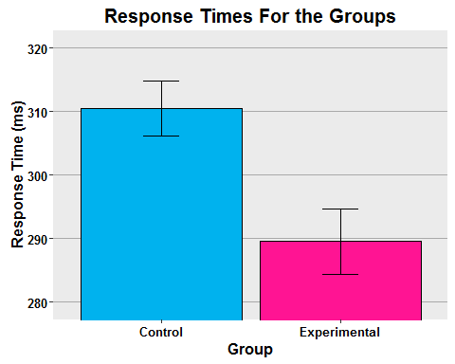

t.test(dat$rt[dat$group=="control"],  
 dat$rt[dat$group=="experimental"],  
 var.equal=TRUE,  
 paired=TRUE)

##   
## Paired t-test  
##   
## data: dat$rt[dat$group == "control"] and dat$rt[dat$group == "experimental"]  
## t = 8.0147, df = 24, p-value = 3.055e-08  
## alternative hypothesis: true difference in means is not equal to 0  
## 95 percent confidence interval:  
## 15.56646 26.36419  
## sample estimates:  
## mean of the differences   
## 20.96533

Individuals in the experimental condition completed the task more quickly than individuals in the control condition, t(24) = 8.01, p < .05.